 | الجمهورية العربية السورية  وزارة التعليم العالي والبحث العلمي  الجامعة السورية الخاصة | 

Smart Survey Platform
Graduation Project 1 Report
Chapters 1–3 (draft for supervisor review, revised 29 October 2026)
Prepared by:
Yaman Bassam Almatar
Yousef Ahmad Alzoubi
Hasan Abdalruhman Yahya
Supervised by:
Eng. Shadi Blidi

Faculty of Artificial Intelligence Engineering
Department of Software Engineering and Information Systems
Project Repository:
https://github.com/Yaman8almatar/smart-survey-platform
Academic Year
2026 – 2027
Table of Contents
Section One: Project Introduction 1
Chapter 1: General Introduction 1
1.1 Project Overview and Background 1
1.2 Problem Statement and Academic Importance 1
1.3 Project Objectives (Main Objective, Sub-Objectives) 2
1.4 Project Scope, Constraints, and Assumptions 3
1.5 Contribution to Knowledge and Field 4
1.6 Research Methodology and Scientific Methods 4
1.7 Document Organization 5
1.8 Basic Definitions and Concepts 5
Chapter 2: Project Development and Management Methodology 7
2.1 Selected Development Methodology and Justification 7
2.2 Project Schedule and Increment Plan 9
2.3 Risk Management 11
2.4 Team Roles and Responsibilities 12
2.5 Quality Management 13
2.6 Project Management Tools 13
2.7 Monitoring and Continuous Evaluation 15
2.8 Software Configuration Management 15
2.8.1 Git Repository Structure 15
2.8.2 Branching and Merging Strategy 16
2.8.3 Development Workflow 16
2.8.4 Tags and Release Management 17
2.8.5 Configuration Items Controlled 17
Section Two: Theoretical Study and Analysis 18
Chapter 3: Literature Review and Related Work 18
3.1 Previous Studies in Smart and Similar Systems 18
3.2 Modern Techniques and Frameworks in the Field 19
3.3 Comparative Analysis of Existing Systems 20
3.4 Research Gap and Proposed Innovation 21
3.5 Theoretical Framework 22
3.6 Modern and Future Trends 23
References (Chapters 1–3) 24

List of Figures
Figure 2.1: Development Process (Kanban with Agile Modeling) 8
Figure 2.2: Gantt Chart of Graduation Project 1 10
Figure 2.3: Product Backlog in GitHub Projects (Table View Grouped by Increment) 14
Figure 2.4: Kanban Board in GitHub Projects (Columns with WIP Limits) 14
Figure 2.5: Branching and Release Flow 16

List of Tables
Table 1.1: Project Objectives 2
Table 1.2: Project Scope, Constraints, and Assumptions 3
Table 1.3: Basic Definitions and Concepts 5
Table 2.1: Definition of Workflow 8
Table 2.2: Increment-Based Project Execution Plan (Forecast) 9
Table 2.3: Risk Register 11
Table 2.4: Team Roles and Responsibilities 12
Table 2.5: Git Repository Structure 15
Table 2.6: Branching Strategy 16
Table 2.7: Release Management 17
Table 3.1: Literature Review Summary 19
Table 3.2: Techniques and Frameworks 20
Table 3.3: Comparison of Existing Platforms 21

Section One: Project Introduction

Chapter 1: General Introduction

1.1 Project Overview and Background
Organisations use surveys to decide how to improve services, products and policies, but a survey result is only as reliable as the people who answered it and the care they took. Online distribution has made surveys cheap to send. It has also made them easy to answer carelessly, fraudulently, or by people outside the intended audience. Open-text answers, which often hold the most useful feedback, are the hardest part of a survey to analyse at scale.
The Smart Survey Platform continues the junior project, the Smart Opinion Survey Platform (V1.0), developed between 1 March and 11 May 2026. V1.0 is a Django web application in which service providers create surveys with demographic targeting criteria, respondents with a stored demographic profile see only the surveys that match them, a database constraint prevents duplicate responses, and open-text answers are sent to an external sentiment model. It was delivered with 22 functional requirements, 10 non-functional requirements, 7 UML diagrams, 9 database entities, 22 web pages and 163 passing automated tests.
Graduation Project 1 extends V1.0 in three directions that answer the limits of the junior project and the supervisors' feedback. First, a Flutter mobile application replaces the static respondent web pages. Second, an extended demographic profile supports richer targeting, and a response-quality engine flags low-quality responses. Third, sentiment analysis of Arabic (Modern Standard Arabic) and English answers uses a model chosen by a measured comparison. Provider and administrator interfaces remain web pages served by Django. The platform is aimed at survey owners and respondents in Syria.

1.2 Problem Statement and Academic Importance
The project addresses three related problems.
No reviewed panel serves Syria. A survey owner in Syria who needs respondents matched by profile has no suitable option among the platforms reviewed in Chapter 3. The panels that target respondents by a stored profile do not list Syria: SurveyMonkey Audience [1] and Prolific [2] do not include it, and Pollfish does not list Arabic among its survey languages [3]. The general survey builders distribute a link, but they do not select respondents by profile.
Quality controls are mostly single-layer. Builders typically offer one response per account or a CAPTCHA, while the evidence shows that one control is not enough. In a study that recruited participants through an open social-media link, 94.5% of 271 completed responses were fraudulent, and all of them passed the CAPTCHA [4]. More recent work shows that automated agents built on large language models now pass attention checks as well (Section 3.1).
Automated analysis of open answers is paid and mostly English. Typeform's Smart Insights labels the sentiment of English forms only [5]. SurveyMonkey offers sentiment analysis on some paid plans without stating the supported languages [6]. Google Forms offers Gemini summaries on paid editions, without a label for each answer [7]. For Arabic answers, the survey owner is left with manual reading.
The junior project solved part of the first problem but left clear limits. Its respondent interface was a set of static web pages; its targeting used gender, age and a free-text region only; it had no quality check beyond duplicate prevention; and the accuracy of its sentiment model was never measured. The hosted inference service it called also returned HTTP 402 (Payment Required) responses at the start of Graduation Project 1, so the analysis did not run.
Academically, the problem combines requirements engineering, a layered architecture, a public REST API, a mobile client, data-quality methods from survey methodology, and the evaluation of natural language processing models for Arabic. Each part has to be justified with evidence and verified with tests, which makes the problem a suitable subject for a software engineering graduation project.

1.3 Project Objectives (Main Objective, Sub-Objectives)
The main objective (OBJ-M) is to build a survey platform that delivers each survey to suitable respondents, detects low-quality responses and analyses the sentiment of open answers, by the end of Graduation Project 1 in January 2027. Each sub-objective follows the SMART form required by the department guide: it is specific, has a measurable outcome, is achievable with the team's resources, is linked to a requirement, and is bound to the Graduation Project 1 schedule. Table 1.1 lists them with the requirements they trace to (Chapter 4).
Table 1.1: Project Objectives
ID | Objective | Measurable Outcome | Req.
OBJ-M | Build a survey platform that reaches suitable respondents, detects low-quality responses and analyses open-answer sentiment. | The five sub-objectives below are met by the Graduation 1 release in January 2027. | FR-01 to FR-20
S-OBJ-01 | Provide a Flutter mobile application for respondents. | Respondents register, complete the demographic profile, see their matching surveys and answer them in the app; every respondent use case of V1.0 is available in the app. | FR-01, FR-02, FR-06
S-OBJ-02 | Target respondents with the extended demographic profile. | Before publishing, the provider sees the number of eligible respondents; the server checks eligibility again when a response is submitted. | FR-03, FR-08
S-OBJ-03 | Flag suspicious responses without deleting them. | Each response stores attention-check, speeding, straight-lining and duplicate-device flags and a quality score; the provider includes or excludes each flagged response. | FR-04, FR-07
S-OBJ-04 | Select the sentiment model by measurement. | At least four candidate models are compared by macro-F1 on 300 labelled answers (150 MSA, 150 English), with results reported per language. | FR-05, NFR-07
S-OBJ-05 | Keep the mobile API responsive. | 95% of API requests are answered within 2 seconds on the demonstration machine with the demonstration data. | NFR-01

1.4 Project Scope, Constraints, and Assumptions
This section defines the boundaries of Graduation Project 1. The scope lists what is built in this phase, the out-of-scope items state what is intentionally left out, the constraints describe the limits under which the work is done, and the assumptions state the conditions expected to hold for the results to be valid.
Table 1.2: Project Scope, Constraints, and Assumptions
Category | Description
In Scope | The 20 functional requirements of Graduation Project 1 (FR-01 to FR-20, detailed in Chapter 4): the respondent mobile application, the extended demographic profile, advanced targeting, the response-quality engine, Arabic and English sentiment analysis, the answering experience with drafts, individual response review, pseudonymous responses, invitation links, the survey lifecycle with administrator review, advanced analytics, export, account security and randomized question order, followed by four lower-priority features (advanced builder, completion analytics, templates and in-app notifications).
Technical Scope | Django 4.2 with Django REST Framework and JSON Web Tokens for the respondent API; Django templates for the provider and administrator pages; Flutter (Dart) for the respondent application on Android and the web; PostgreSQL 15 in Docker; pretrained sentiment models reached through a gateway class; GitHub Actions for continuous integration.
Out of Scope | Five requirements deferred to Graduation Project 2: respondent rewards (FR-21), skip logic and conditional branching (FR-22), an administrator dashboard (FR-23), respondent trust levels (FR-24) and provider notifications (FR-25). Also excluded: training or fine-tuning a model, an iOS build, an Arabic user interface, push notifications, measuring sentiment accuracy on dialectal Arabic, and production deployment.
Constraints | About ten weeks of development between 2 November 2026 and the report deadline of 16–19 January 2027, fixed by the university calendar; a team of three students with limited prior Flutter experience; development on a shared Windows laptop on joint working days and on each member's own computer on remote days; pretrained models only; dependence on the availability, speed and cost of the chosen model's hosting.
Assumptions | Respondents enter accurate demographic data; public labelled datasets are enough to build an evaluation set that is independent of every candidate model's training data; the supervisors review the Increment every two weeks; the demonstration runs on one machine with seeded demonstration data.

1.5 Contribution to Knowledge and Field
The project does not propose a new machine learning model. Its contribution is the engineering integration and the evaluation of existing methods for a setting that the reviewed platforms do not serve:
- It combines, in one platform aimed at Syrian respondents, the profile-matched targeting that commercial panels sell with the layered quality signals that the survey-methodology literature recommends, and with built-in sentiment analysis of each open answer in Arabic and English.
- It selects the sentiment model by a documented comparison on a labelled set that is independent of the candidates' training data, instead of by popularity, and reports the result per language.
- It records quality flags instead of deleting responses, so the analyst can see how each exclusion changes the results, as the literature recommends (Section 3.5).

1.6 Research Methodology and Scientific Methods
This report follows an engineering (design-and-build) research methodology: the problem is analysed, requirements are derived, a system is designed and built, and the result is verified against measurable objectives. The software development methodology that organises this work in time is described separately in Chapter 2.
Within this methodology the project uses the following methods. Comparative analysis benchmarks six survey platforms on the same criteria using their official help pages (Section 3.3). Document analysis covers published studies (Section 3.1) and the V1.0 source code. Stakeholder input comes from supervisor meetings on 22 and 24 October 2026 and from the two-weekly reviews of each Increment. Prototyping produced the respondent REST API and the first Flutter screens during Iteration 0. Experimental evaluation is used twice: to select the sentiment model by macro-F1 on a fixed labelled set, with confusion matrices per language, and to measure API response times against NFR-01.

1.7 Document Organization
The document follows the department's graduation thesis guide. Section One introduces the project (Chapter 1) and the development and management methodology (Chapter 2). Section Two presents the literature review (Chapter 3) and requirements modelling and analysis (Chapter 4). Section Three documents the architectural design (Chapter 5). Section Four covers the implementation environment, the implementation and the testing (Chapters 6 to 8). Section Five presents results and conclusions (Chapters 9 and 10), and Section Six contains the appendices and references. This version contains Chapters 1 to 3; its references are numbered in order of first use and are renumbered when the full report is assembled.

1.8 Basic Definitions and Concepts
Table 1.3 defines the terms used throughout this report.
Table 1.3: Basic Definitions and Concepts
Term | Definition
Targeting criteria | The demographic conditions a provider sets on a survey (for example gender, age range, governorates) that a respondent must meet to see it.
Eligibility check | The server-side test of a respondent's profile against a survey's targeting criteria, run when surveys are listed and again when a response is submitted.
Attention check | An instructed-response question with a known correct answer, used to detect respondents who do not read the questions.
Speeding | Completing a survey much faster than the typical respondent; measured relative to the survey's median completion time.
Straight-lining | Giving the same answer to a series of rating questions regardless of their content.
Quality score | A per-response value derived from the quality flags; flagged responses are kept and the provider decides whether to include them.
Pseudonymous response | A response linked to an account known to the platform, while the survey provider sees only demographics, never the respondent's name or email.
Sentiment analysis | Classifying a text as positive, neutral or negative.
Modern Standard Arabic (MSA) | The standard written form of Arabic, as opposed to regional spoken dialects such as Levantine Arabic.
Macro-F1 | The unweighted average of the F1 scores of all classes; it gives a minority class such as neutral the same weight as the others.
REST API | A web interface that exposes resources at URLs and exchanges JSON over HTTP without server-side session state.
JSON Web Token (JWT) | A signed token that carries the user's identity; the mobile app sends it with every API request.
Throttling | Limiting how many requests a client may send to an endpoint in a time window; excess requests receive HTTP 429.
Layered architecture | An organisation of the application into presentation, business and data source layers, where each layer uses only the layer below it.
Service Layer / Repository / Gateway | Design patterns: services define the application's operations; repositories give collection-like access to stored domain objects; a gateway wraps access to an external system.
Product Backlog | The ordered list of everything needed in the product; in this project, GitHub issues in a GitHub Project, pulled in priority order.
Increment | A two-week delivery period, and the usable, tested version of the product that is released to the main branch at its end.
Kanban | A method for managing work as a visible flow of work items through explicitly defined states, with explicit limits on the work in progress.
WIP limit | The maximum number of work items allowed in a workflow state at the same time; new work is pulled only when the count is below the limit.
Flow metrics | Work in progress, throughput (items finished per unit of time), work item age and cycle time (time from start to finish of an item).
Definition of Done | The quality conditions every backlog item must meet before it counts as finished.
MoSCoW | A prioritisation method that labels requirements Must, Should, Could or Won't have this time.

Chapter 2: Project Development and Management Methodology

2.1 Selected Development Methodology and Justification
The project is managed with Kanban as defined in the Kanban Guide [8], combined with Agile Modeling practices for design work [9]. Development remains iterative and incremental: specification, development and validation are interleaved, and every two weeks a tested Increment is released and reviewed with the supervisors [10].
Four reasons support this choice. First, the team works in a hybrid pattern: on some days the three members work together, and on other days each works alone from home. Scrum, which the team adopted first, defines a Daily Scrum held at the same time and place every working day and separate Product Owner and Scrum Master accountabilities, and its guide states that implementing only parts of Scrum does not produce Scrum [11]; the team could not hold these events in their defined form. Kanban prescribes no roles, events or location; its minimum is an explicit Definition of Workflow, explicit control of the work in progress (WIP) and four flow metrics [8], all of which the team can apply and show from its GitHub records. Second, the requirements changed several times through supervisor feedback before development started: the respondent interface moved from web pages to a mobile application, provider and administrator interfaces were kept on the web, the supported Arabic varieties were revised, and the number of Graduation Project 1 requirements was settled at 20 after two review rounds; continuous pulling from an ordered backlog absorbs such changes without re-planning a fixed scope. Third, the university calendar fixes the dates of the seminars, the report and the defence, so the team adds a two-week delivery cadence to the flow. Fourth, studies of student projects support the choice: in a controlled comparison of four approaches in semester-long data science student projects, a Kanban approach was much more effective than Scrum [12], and a study of Scrum in software capstone courses found that daily stand-up meetings in every class were not helpful and that Scrum had to be adapted to students' workloads and schedules [13].
Three alternatives were rejected. Crystal Clear suits small teams but requires osmotic communication, which depends on the members working close together [14]; on the days the members work from home this property cannot hold. Waterfall was rejected because the requirements were not stable, and the Unified Process because its phases and artefact set are heavier than a three-person team can maintain in ten weeks. Kanban has also been reported to be effective in distributed teams, although with challenges that need explicit policies [15]; the team's policies are listed in Table 2.1.
Agile Modeling adds the design discipline. Iteration 0 (22 October to 1 November 2026) performed initial requirements envisioning and architecture envisioning: the requirements and their priorities, the use case diagrams, the architecture diagram, an initial class (domain) diagram and a prototype. After Iteration 0, modelling happens when an item is pulled: model storming produces the diagrams the item needs, such as sequence and activity diagrams and the ERD, so diagrams are drawn just before the code they describe. Figure 2.1 shows the resulting process.
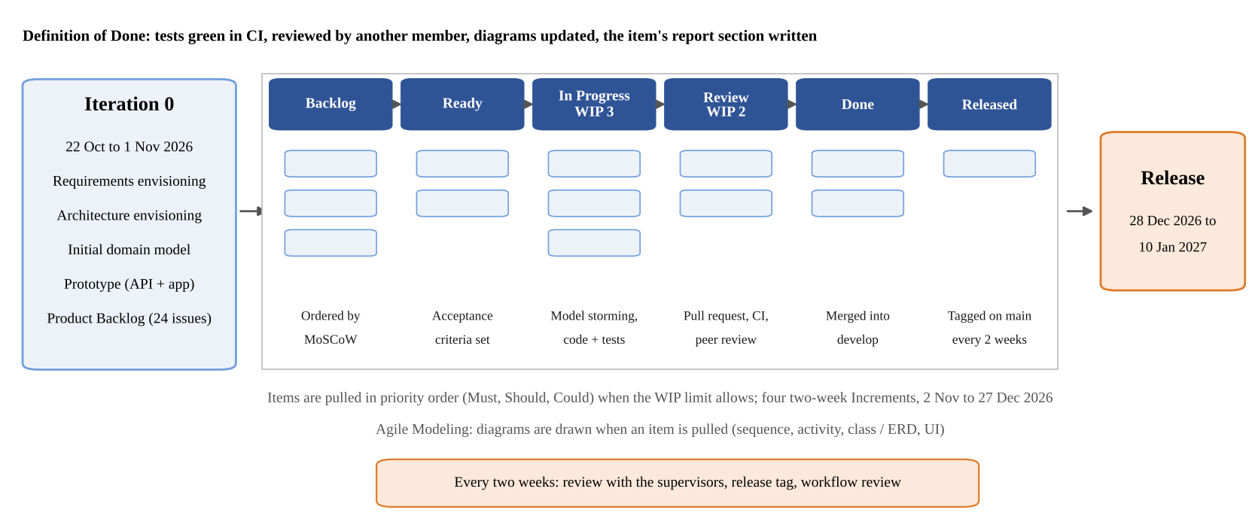
Figure 2.1: Development Process (Kanban with Agile Modeling)
Table 2.1 gives the Definition of Workflow, the explicit agreement that the Kanban Guide requires [8]. A work item is one backlog issue. Work on an item starts when its branch is created and finishes when its pull request is merged into the integration branch; the release of the Increment to the main branch is recorded as a further state. The service level expectation is an initial estimate, as the guide allows until enough cycle-time data exists, and it is recalculated after the first two weeks [8]. The Definition of Done requires that the automated tests pass in continuous integration, that another member has reviewed the pull request, that the affected diagrams are updated and that the item's report section and defence questions are written.
Table 2.1: Definition of Workflow
Element | In this project
Work items | One backlog issue: a requirement FR-01 to FR-20 written as a user story, or a technical item (T-1 to T-5).
Start and finish | Started when the item's branch is created; finished when its pull request is merged into develop. The release to main is recorded as the state Released.
States | Backlog, Ready, In Progress, Review, Done, Released.
WIP control | In Progress: at most 3 items (one per member). Review: at most 2 items. Shown as column limits on the board; a member pulls new work only below the limit.
Policies | An item enters Ready only with acceptance criteria and a MoSCoW priority; items are pulled in the order Must, Should, Could; a pull request is reviewed by a member who did not write it; an item moves to Done only when it meets the Definition of Done; blocked items are labelled and answered within 24 hours.
Service level expectation | Initial estimate: 85% of items finish within 7 days. Recalculated from measured cycle times after the first two weeks.

2.2 Project Schedule and Increment Plan
The schedule runs from Iteration 0 to the final judging in February 2027. Four two-week increments run from 2 November to 27 December 2026, followed by a release period for system testing, performance measurement and the final report. Because items are pulled in priority order, the allocation of requirements to increments is a forecast, not a fixed commitment; it follows priority and dependency: FR-05, for example, is a Must requirement but is expected in Increment 3, because it needs the model selected by the evaluation (T-2) in Increment 2. A feature freeze on 27 December protects the release period. Table 2.2 lists the forecast, and Figure 2.2 shows it as a Gantt chart with the university milestones.
Table 2.2: Increment-Based Project Execution Plan (Forecast)
Increment | Period | Backlog Items | Main Deliverables
Iteration 0 | 22 Oct – 1 Nov 2026 | Envisioning, prototype | Literature review and platform benchmark; FR-01 to FR-20 and NFR-01 to NFR-07 with MoSCoW priorities; use case, architecture and initial class diagrams; Product Backlog on a Kanban board; REST API and Flutter login, registration and survey list; Seminar 1.
Increment 1 | 2 – 15 Nov 2026 | FR-01, FR-02, FR-06, FR-08, FR-16, T-1, T-4, T-5 | Respondent app features: extended profile, answering with drafts, ranked survey list, randomized order; HTTP 409 for concurrent duplicate submissions; throttling of the authentication endpoints; flow-metrics report (T-5).
Increment 2 | 16 – 29 Nov 2026 | FR-03, FR-04, FR-07, FR-09, T-2 | Advanced targeting with eligible-respondent count; quality engine; individual response view; pseudonymous responses; sentiment model evaluation.
Increment 3 | 30 Nov – 13 Dec 2026 | FR-05, FR-10, FR-11, FR-12 | Arabic and English sentiment analysis with the selected model; invitation links; scheduling, pause and automatic close; administrator review.
Increment 4 | 14 – 27 Dec 2026 | FR-13 to FR-15, then FR-17 to FR-20 | Advanced analytics, export, account security; then the Could items as time allows. Feature freeze on 27 December.
Release | 28 Dec 2026 – 10 Jan 2027 | T-3 | System testing, performance measurement against NFR-01, Seminar 2 (2–5 January), final report.

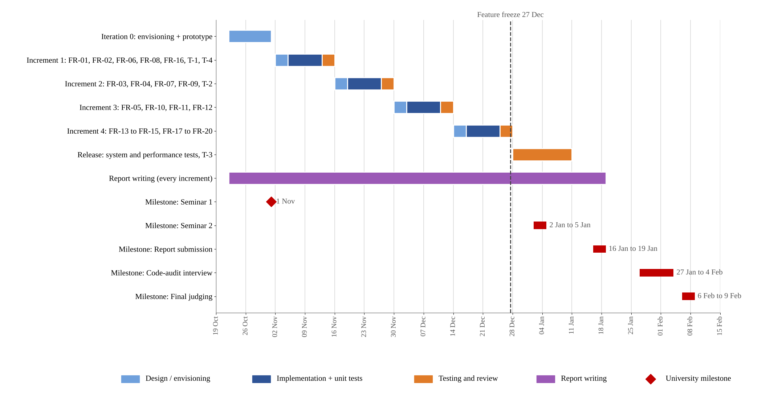
Figure 2.2: Gantt Chart of Graduation Project 1
University milestones: Seminar 1 on 1 November 2026; Seminar 2 on 2–5 January 2027; report submission on 16–19 January 2027; technical code-audit interview on 27 January – 4 February 2027; final judging on 6–9 February 2027.

2.3 Risk Management
Risks are reviewed at each weekly replenishment and at each two-week review. Table 2.3 lists the register at the end of Iteration 0. Risk IDs use the prefix RK so that they are not confused with requirement IDs.
Table 2.3: Risk Register
ID | Risk | Prob. | Impact | Mitigation
RK-01 | The external sentiment model service is unavailable, slow or paid. | Medium | High | The response is stored first; open answers are analysed afterwards and shown as pending until then (NFR-01). Cost and latency are selection criteria in T-2.
RK-02 | The selected model performs poorly on real survey answers, since published benchmarks use tweets and reviews. | Medium | High | Selection by macro-F1 on a labelled set, results per language with confusion matrices, and the limits stated in the report.
RK-03 | Test-set leakage inflates a candidate model's score. | Medium | High | The evaluation set must not overlap any candidate's training data (NFR-07); a candidate trained on the chosen data is excluded or tested on other data.
RK-04 | Limited Flutter experience delays the respondent app. | Medium | High | A minimal stack (http, secure storage, Navigator and setState); screens designed before coding; app work starts in Increment 1.
RK-05 | Twenty requirements exceed the available time. | High | High | MoSCoW order; Could items pulled last and dropped first; feature freeze on 27 December.
RK-06 | Automated or AI-assisted respondents distort results. | Medium | High | Login-bound responses, one response per account, device flags, speeding and pattern checks; flags kept for the analyst.
RK-07 | The public authentication endpoints are abused (password guessing, mass registration). | Medium | Medium | Throttling of login, token refresh and registration with HTTP 429 in Increment 1 (T-4) [16].
RK-08 | Concurrent duplicate submissions return HTTP 500 instead of 409. | Medium | Medium | The unique constraint keeps the data correct; the status code is fixed in Increment 1 (T-1).
RK-09 | Django 4.2 no longer receives security fixes: its extended support ended in April 2026 [17], and the project pins 4.2.11. | High | Medium | Evaluate an upgrade to Django 5.2 LTS early in Increment 1, using the automated test suite as the safety net.
RK-10 | Requirements change after a two-week review. | Medium | Medium | The Product Backlog is reordered at the next replenishment; each change is recorded with its reason in the decision log.
RK-11 | A member's computer fails or is lost. | Low | Medium | Work is pushed to GitHub at the end of every working session; documents are kept in the repository.
RK-12 | Work done in parallel on remote days diverges or stalls. | Medium | Medium | The board is the single status record; WIP limits; a written check-in on remote days; blocked items labelled and answered within 24 hours; every pull request reviewed by another member.
RK-13 | A change reaches develop or main without review or a passing CI run. | Medium | High | Branch protection on develop and main requires a pull request and passing checks; the history is checked before each release.

2.4 Team Roles and Responsibilities
The three students form one Kanban team. Kanban defines no roles [8], so the team assigns process responsibilities instead (Table 2.4). Each member also leads one technical area, and all three develop, test, review and document. On some days the members work together and on others each works alone from home; every commit credits only the teammates who took part in it. The supervisors are the main stakeholders and review the Increment every two weeks.
Table 2.4: Team Roles and Responsibilities
Member | Process Responsibility | Technical Area | Main Responsibilities
Yaman Almatar | Backlog order and supervisor contact; Developer | Backend and architecture | Orders the Product Backlog, writes acceptance criteria and prepares the two-week reviews; Django services, REST API, database design and architectural consistency.
Yousef Alzoubi | Board, WIP policies and flow metrics; Developer | Frontend | Keeps the board and its policies current and reports the flow metrics at each review; Flutter respondent app and the provider and administrator web pages.
Hasan Yahya | AI items; Developer | AI and analysis | Sentiment model evaluation (T-2) and integration; analysis features that use sentiment and quality data.
Eng. Shadi Blidi, | Stakeholders (supervisor) | Academic supervision | Review the Increment every two weeks; approve requirements and scope changes; guide the methodology and documentation.

2.5 Quality Management
Quality is built into each backlog item instead of being checked at the end. The non-functional requirements are written against the product quality model of ISO/IEC 25010:2023 [18] (Chapter 4), and the following controls apply to every backlog item:
- Acceptance criteria and Definition of Done. Every backlog item states testable acceptance criteria; an item is done only when its tests pass in continuous integration, another member has reviewed it, its diagrams are updated and its report section is written.
- Automated tests in continuous integration. The Django CI workflow runs the backend tests against a PostgreSQL 15 service on every push and pull request to main and develop. The Flutter CI workflow runs static analysis (flutter analyze) and the widget and unit tests whenever the app changes. At the end of Iteration 0 the backend has 259 test functions (about 330 test cases after parametrisation) and the app has 34 tests.
- Pull requests merged only after review and on green checks. Each task is integrated through a pull request that a member who did not write it reviews; the team merges it only after the CI checks have passed.
- Architectural rules. Presentation code calls services only; services reach data only through repositories and the gateway class [19]. A check of the code at the end of Iteration 0 found no view that imports a repository or runs a database query.
- Traceability. Each requirement is linked to its use cases, its backlog issue, the pull requests that implement it and the tests that verify it.
- Known defects as backlog items. Defects found by audits are recorded as backlog items with an owner and a target increment, for example T-1 (concurrent duplicate submissions return HTTP 500 instead of 409).

2.6 Project Management Tools
The Product Backlog and the Kanban board are kept in GitHub Projects, linked to the project repository. Each requirement FR-01 to FR-20 is an issue written as a user story with acceptance criteria, together with five technical items: T-1 (the HTTP 409 fix), T-2 (the model evaluation), T-3 (the performance measurement), T-4 (the throttling of the authentication endpoints) and T-5 (the flow-metrics report). The project has custom fields for the MoSCoW priority, the requirement ID, the increment (an iteration field with two-week iterations from 2 November 2026) and the status, whose options are the workflow states of Table 2.1. Three views serve different purposes: a backlog table grouped by increment (Figure 2.3), a Kanban board with one column per state and column limits on In Progress and Review (Figure 2.4), and a roadmap of the increments over time. Each increment also has a repository milestone, and the project description states the Definition of Workflow.
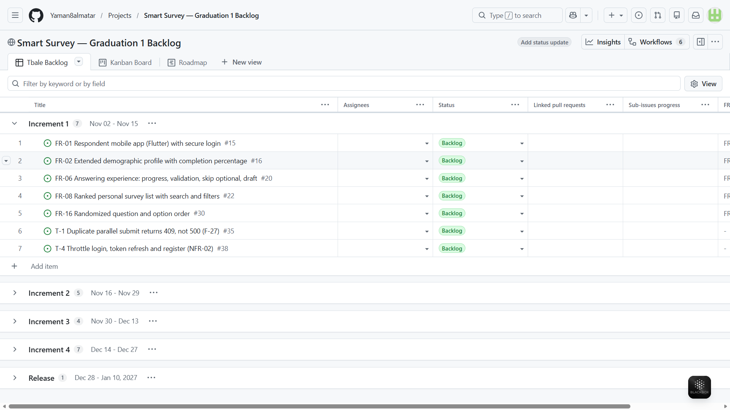
Figure 2.3: Product Backlog in GitHub Projects (Table View Grouped by Increment)
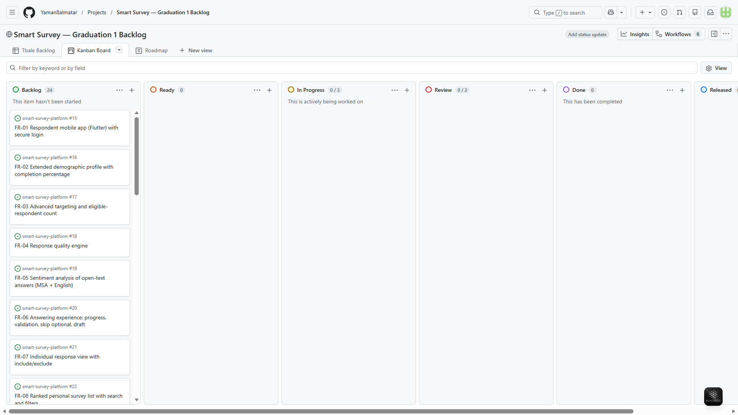
Figure 2.4: Kanban Board in GitHub Projects (Columns with WIP Limits)
GitHub Projects was preferred over Jira because the issues, the pull requests that implement them and the CI results live in the same place: a requirement links directly to the code and tests that satisfy it, and no second system has to be kept in sync by hand. The schedule is maintained as a Gantt chart (Figure 2.2), and a decision log records each project decision with its reason and the rejected alternative.

2.7 Monitoring and Continuous Evaluation
Progress is monitored at three levels. Continuously, the board shows the state of every item, the column limits show when the WIP limit is reached, and the CI result of each pull request shows whether the work meets the Definition of Done. Every two weeks, the review with the supervisors presents the Increment and collects their feedback, the four flow metrics are reported (WIP, throughput, work item age and cycle time), and a short workflow review decides which policies the team changes [8]. At the phase level, Seminar 1 and Seminar 2 are external checkpoints where the committee reviews the plan and the results.
The project insights show the current number of items in each state and a burn-up chart of completed items. Cycle time and work item age are measured from the first commit on an item's branch to the merge of its pull request, from data exported with the GitHub command-line tool (T-5). Because issues close only when an Increment is released to the main branch (Section 2.8.4), the number of closed issues per release also gives a simple measure of the delivered scope.

2.8 Software Configuration Management
Software Configuration Management (SCM) controls the changes to source code, dependencies, database migrations, configuration and documentation. The project is versioned with Git and hosted on GitHub in the repository Yaman8almatar/smart-survey-platform.

2.8.1 Git Repository Structure
Since Graduation Project 1 adds a mobile application to the existing web system, the repository was reorganised into a monorepo at the start of this phase, so the backend, the app, the diagrams and the documents are versioned together. Table 2.5 lists its main elements.
Table 2.5: Git Repository Structure
Repository Element | Purpose
backend/ | Django project: apps (models, views, REST API), services, repositories, infrastructure (external model client), templates, static files and tests.
frontend/ | Flutter respondent application: source code (lib/) and tests (test/).
diagrams/ | Diagram exports (PNG): the class diagram and the three use case diagrams; the architecture diagram is in the Seminar 1 slides.
documentation/ | Junior project documents and the Graduation Project 1 report and slides.
planning/ | Project status, the Kanban workflow definition, the REST API contract and the backend audit.
.github/workflows/ | Continuous integration: Django CI and Flutter CI.
docker-compose.yml | PostgreSQL 15 for local development, the single database source.
README.md, CONTRIBUTING.md | Project description, setup instructions, and branching and commit rules.

2.8.2 Branching and Merging Strategy
The branching model separates releases, integration and individual tasks (Table 2.6 and Figure 2.5). Task branches are short-lived and squash-merged into develop, so each task appears as one commit. Releases from develop to main use a merge commit instead of a squash: a squashed release would give main a commit that develop does not contain, and the next release would replay the same changes. An urgent change to a released version, such as a correction of the released documents, is made on a hotfix branch from main, merged into main as a patch release and then merged back into develop.
Table 2.6: Branching Strategy
Branch | Purpose
main | Default branch; holds released, tagged versions only.
develop | Integration branch; receives every completed task.
feature/<name> | A new feature from the backlog.
fix/<name> | A defect fix.
chore/<name>, docs/<name> | Tooling, configuration or documentation changes.
hotfix/<name> | An urgent change to a released version: branched from main, merged into main as a patch release, then merged back into develop.

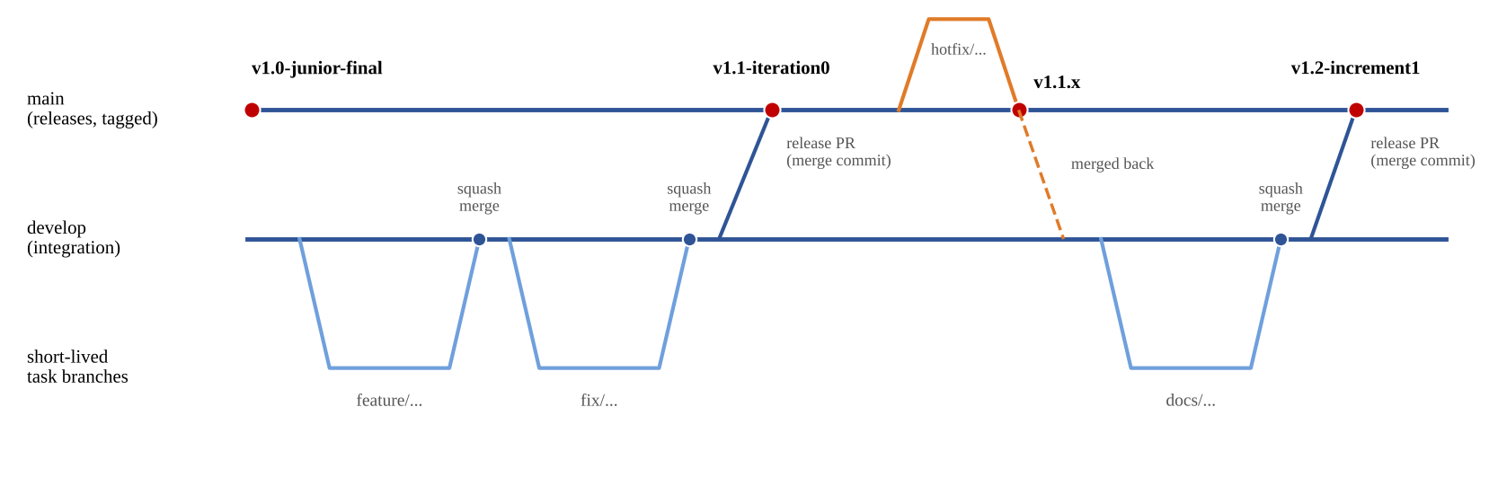
Figure 2.5: Branching and Release Flow

2.8.3 Development Workflow
Each backlog item follows the same workflow:
- At the weekly replenishment the item moves from Backlog to Ready, with acceptance criteria and a MoSCoW priority.
- When a member is below the WIP limit, he pulls the next Ready item, moves it to In Progress and creates a short-lived branch from develop.
- The change is implemented together with its tests and diagrams, in small commits that credit every teammate who took part.
- A pull request to develop is opened; it references the backlog issue, and the item moves to Review.
- A member who did not write the change reviews it and the CI workflows run; the pull request is squash-merged only when both pass, the branch is deleted and the item moves to Done.
- At the two-week review, develop is merged into main by a release pull request and the release is tagged; the issues referenced by its pull requests close and move to Released.

2.8.4 Tags and Release Management
GitHub closes an issue automatically only when the pull request that references it reaches the default branch, which is main. Issues therefore close when an Increment is released, which makes each release a clear record of the scope delivered in that increment. Table 2.7 lists the release plan.
Table 2.7: Release Management
Tag | Content
V1.0, v1.0-junior-final | Junior project release (May 2026).
v1.1-iteration0 | End of Iteration 0: Seminar 1 outputs, diagrams, REST API and the first Flutter screens (28 October 2026).
v1.1.1 | Patch release: the local tool configuration is no longer tracked (28 October 2026).
v1.1.2 | Patch release (hotfix): the slides, this report, the README and the contribution guide updated for the Kanban method (before Seminar 1).
v1.2-increment1 to v1.5-increment4 | The Increment of each two-week period, released at its review with the supervisors.
Graduation 1 release | The version submitted with the report in January 2027.

2.8.5 Configuration Items Controlled
The controlled configuration items are the source code of the backend and the app; the dependency files (backend/requirements.txt, frontend/pubspec.yaml and pubspec.lock); the database migrations; docker-compose.yml; the CI workflow files; the diagram sources; the API contract; and the documentation. Secrets such as the Django secret key, database credentials and model API tokens are never committed: they are read from environment variables, and an .env.example file documents the variables without their values.

Section Two: Theoretical Study and Analysis

Chapter 3: Literature Review and Related Work

3.1 Previous Studies in Smart and Similar Systems
The review covers two strands that match the two core problems of the project: the quality of online survey data, and the automatic analysis of the sentiment of Arabic and English text. Nine studies from 2021 to 2025 were selected because each one measures something that a design decision in this project depends on. Table 3.1 summarises them.
Data quality of online respondents. Peer et al. compared online platforms and panels and found that the share of participants who passed both attention checks ranged from 68.7% on Prolific to 22.1% on Dynata; how often and awhy participants used a platform predicted data quality better than their approval ratings [20]. Three of the five authors are affiliated with Prolific, which the reader should keep in mind. Douglas et al. compared five sources and found that Prolific and CloudResearch participants were more likely to pass attention checks, give meaningful answers, follow instructions, have unique IP addresses and locations, and work slowly enough to read the items; among the paid sources, the cost per high-quality respondent ranged from USD 1.90 on Prolific to USD 8.17 on Qualtrics panels [21]. Ward and Meade reviewed how to prevent, identify, report and remove careless responses, and proposed screening recommendations at several levels of strictness [22].
The arrival of AI respondents. Westwood built an autonomous agent that passed 99.8% of attention checks across 43,000 tests and was not identified by the detection methods he tested; each fake response cost about USD 0.05, and adding 10 to 52 such responses would have flipped the predicted outcome of seven national polls before the 2024 United States election [23]. Zhang, Xu and Alvero found that 34% of participants recruited from an online platform reported using large language models to help answer open-ended questions, and that text written by these models was more homogeneous and more positive than human answers, especially for sensitive questions about social groups [24]. For this project, the second finding matters directly: AI-assisted answers can shift sentiment results towards positive.
Arabic sentiment analysis. Abu Farha and Magdy benchmarked 24 transformer models on Arabic sentiment in dialectal tweets; MARBERT and AraBERT-large reached the best F1-PN of 0.724, against 0.625 for multilingual BERT [25]. Al-Thubaity et al. found that GPT-4 outperformed GPT-3.5 and Bard on dialectal Arabic sentiment and came close to a fully supervised Arabic BERT model [26]. Khondaker et al. evaluated ChatGPT on 44 Arabic tasks across more than 60 datasets and found it consistently surpassed by smaller models fine-tuned on Arabic, with weaker results on dialects than on MSA [27]. Finally, Lossio-Ventura et al. compared methods on real open-ended survey answers in English: lexicon-based tools reached 0.43–0.66 accuracy, a tweet-trained RoBERTa model 0.72–0.78, and ChatGPT 0.86–0.87, and the authors recommend validating any tool against human labels [28].
Together the studies show that data quality varies widely between respondent sources and has to be measured, that single checks are no longer sufficient, and that for Arabic sentiment a fine-tuned Arabic model remains a strong and cheap option while large language models are competitive and improving. None of the studies provides a platform that serves Syrian respondents, and only one evaluates sentiment methods on survey answers, in English.
Table 3.1: Literature Review Summary
Reference | Focus | Main Finding | Gap for This Project
Peer et al., 2022 [20] | Platform data quality | Attention-check pass rates from 68.7% to 22.1% by platform. | Measures panels; offers no platform for Syria.
Douglas et al., 2023 [21] | Platform data quality | Two platforms clearly better on attention, effort and unique IPs; cost per good respondent USD 1.90–8.17. | Commercial panels; quality checks outside the survey tool.
Ward & Meade, 2023 [22] | Careless responding | Prevention, identification, reporting and removal, with screening levels. | Method guidance only; implementation left to the researcher.
Westwood, 2025 [23] | AI respondents | An AI agent passed 99.8% of attention checks and evaded detection. | Shows the threat; no platform-level defence evaluated.
Zhang, Xu & Alvero, 2025 [24] | AI-assisted open answers | 34% of participants used LLMs; answers more homogeneous and positive. | No detection method in a production system.
Abu Farha & Magdy, 2021 [25] | Arabic sentiment models | 24 models compared; best F1-PN 0.724 (MARBERT, AraBERT-large). | Tweets, not survey answers.
Al-Thubaity et al., 2023 [26] | LLMs for Arabic sentiment | GPT-4 near a supervised Arabic BERT on dialectal sentiment. | Social-media text; no survey domain.
Khondaker et al., 2023 [27] | LLMs on Arabic NLP | Smaller fine-tuned Arabic models beat ChatGPT on 44 tasks. | General benchmarks; no survey domain.
Lossio-Ventura et al., 2024 [28] | Sentiment of survey answers | Lexicons 0.43–0.66, RoBERTa 0.72–0.78, ChatGPT 0.86–0.87 accuracy. | English only.

3.2 Modern Techniques and Frameworks in the Field
Table 3.2 lists the main technologies used in Graduation Project 1 and the reason for each choice. The backend keeps the Django code base of V1.0, whose business rules are independent of HTTP, and adds a REST API for the mobile app.
Table 3.2: Techniques and Frameworks
Technology | Role in Smart Survey | Reason for the Choice
Django 4.2 (MVT) | Provider and administrator web pages; models, services and repositories. | Existing V1.0 code base with its tests; Django's model-template-view form of MVC [29]. Its extended support ended in April 2026 (risk RK-09).
Django REST Framework + Simple JWT | JSON API at /api/v1/ for the respondent app. | Reuses the existing services; token authentication that suits a mobile client [30].
Flutter (Dart) | Respondent mobile application. | One code base for Android and the web; the supervisors asked for an interactive mobile interface.
PostgreSQL 15 in Docker | Relational data store. | Constraints enforce data integrity (for example one response per respondent per survey); one compose file for every developer.
Pretrained transformer models | Sentiment classification of open answers. | Arabic models such as AraBERT [31], CAMeLBERT [32] and MARBERT [33], built on BERT [34], reach strong Arabic sentiment results without training by the team.
Large language models through an API | Candidate in the model comparison (T-2). | Competitive on Arabic sentiment [26]; included so the choice is made by measurement, not assumption.
GitHub Actions | Continuous integration. | Runs the backend and app tests on every pull request in the same place as the code and the backlog.

For Arabic text, the key result for model choice is that the closeness of the pre-training data to the target text matters more than the size of the pre-training corpus: CAMeLBERT trained on MSA reached 93.0 F1-PN on the ArSAS dataset, against 88.4 for multilingual BERT [32]. Since the project analyses MSA and English, MSA-pretrained and multilingual models are both candidates, and the comparison in Increment 2 (T-2) decides between them.

3.3 Comparative Analysis of Existing Systems
Six platforms were compared on the three capabilities that define Smart Survey: targeting respondents by profile, checking response quality, and analysing the sentiment of open answers. Three are survey builders, where the owner brings the respondents, and three are panels, which sell access to profiled respondents. Table 3.3 summarises the comparison. Facts were taken from the platforms' official help pages between 23 and 27 October 2026; "not stated" means that the pages read do not state the feature, not that the feature is certainly missing.
Table 3.3: Comparison of Existing Platforms
Platform | Type | Targeting | Quality Checks | Sentiment of Open Answers | Main Weakness
Google Forms | Builder | None | One response per Google account [35] | Gemini summaries on paid Workspace plans; no per-answer label [7] | No targeting
Typeform | Builder | None | reCAPTCHA; duplicate prevention by cookie on upper plans [36] | Smart Insights on upper plans; English only [5] | Duplicate check bypassed by clearing cookies
SurveyMonkey | Builder | Only through the paid Audience panel | One response per respondent; IP blocking [37] | On some paid plans; languages not stated [6] | Targeting is a separate product
SurveyMonkey Audience | Panel | More than 200 options [38] | Machine learning replaces poor responses [38] | Not stated [39] | Syria not listed [1]
Prolific | Panel | More than 300 filters | Identity checks, fast-submission flags, quality scores [40] | Not applicable: surveys are hosted elsewhere | Syria not listed [2]
Pollfish | Panel | Demographic and geographic | Automated fraud detection; discards up to 30% [41] | Not stated in the results dashboard [42] | Arabic not supported [3]
Smart Survey (planned) | Platform | Extended profile; Syrian governorates | Layered: attention, speeding, straight-lining, duplicate device, quality score | Built in for each answer; MSA and English | In development until January 2027; respondent pool still small

3.4 Research Gap and Proposed Innovation
Gap. None of the six platforms combines profile-based targeting that reaches Syria, layered quality checks, and built-in sentiment analysis of each open answer in Arabic. The builders lack targeting and rely on single checks; the panels target and check quality but do not list Syria or Arabic; and sentiment features are paid, mostly English, or absent.
Proposed innovation. Smart Survey brings the panels' core idea, stored respondent profiles matched to surveys, to a population the panels do not serve, and adds the layered quality signals that the literature recommends. Each response is identified by a logged-in account, carries several flags and a quality score, and is kept for the analyst to include or exclude. Each open answer receives a sentiment label from a model selected by measurement.
Limits stated in advance. Three limits follow from the literature and are reported, not hidden. First, targeting controls who answers, but a targeted sample is not a representative sample, so results are described as targeted. Second, published Arabic sentiment results come from tweets and reviews, and the project's evaluation set is built from public labelled data, so accuracy on real Syrian survey answers remains an open question; dialect answers are classified, but accuracy on dialect is not measured in this phase. Third, AI-assisted and automated respondents can pass attention checks [23] and make answers more positive [24], so the quality flags reduce this risk but cannot remove it.

3.5 Theoretical Framework
Architecture. The system follows a three-tier client-server style with a layered application tier [10]. Inside the Django server, the layers follow Fowler's presentation, domain and data source layers, called here the Presentation, Business and Data Source layers [19]. Four patterns from the same catalogue implement them: the Service Layer defines the application's operations; Repositories give collection-like access to stored objects; Django models are Active Record objects; and a Gateway class wraps access to the external sentiment service. The REST API follows the constraints described by Fielding, notably stateless requests and resources identified by URLs [43], and authenticates requests with JSON Web Tokens [30].
Sentiment classification. The candidate models are transformer encoders pretrained on large text corpora and then fine-tuned by their authors for sentiment classification [34]; the project uses them as they are, without further training. Models are compared with the F1 score of each class c, F1_{c} = 2 × P_{c} × R_{c} / (P_{c} + R_{c}), where P_{c} is the precision and R_{c} the recall of class c, and with the macro-F1, the unweighted mean of F1_{c} over the positive, neutral and negative classes. The macro average is used because survey answers contain many neutral texts, and a model that ignores a class must be penalised even if its overall accuracy looks good. A confusion matrix per language shows which classes a model confuses.
Response-quality signals. Instructed-response items detect respondents who do not read the questions; several items are better than one, and the analysis should report results by attention level instead of silently dropping respondents, because passing correlates with respondent traits [44]. Speeding is measured against the median completion time: flagging respondents 30%, 40% or 50% faster than the median flags about 20%, 14% and 9% of respondents, and removing them changes regression results more than simple distributions [45]. Network and device checks catch repeated or foreign participation; screening IP addresses at the start of a survey blocked all foreign and virtual-server users in one study [46]. These results justify flags rather than automatic deletion.
Privacy and measurement design. Pseudonymous analytics hide any group smaller than five respondents, an application of k-anonymity, in which each released record is indistinguishable from at least k−1 others [47]. The order of answer options affects which option is chosen, so the order of questions and options is randomized per respondent where the provider enables it [48]. Requirements are prioritised with MoSCoW [49].

3.6 Modern and Future Trends
Language models as coders of open answers. Large language models are starting to replace manual coding of open-text survey answers. Mellon et al. found that the best model they tested assigned 50 issue categories with 93.9% accuracy, close to a second human coder at 94.7%, and better than supervised models trained on 1,000 labelled cases [50]. For sentiment, a broad evaluation found that large language models do well on simple sentiment tasks and in few-shot settings, which suits languages and domains with little labelled data, but lag on complex sentiment tasks [51]. For Arabic, smaller fine-tuned models still lead on most tasks [27], so the balance between a fine-tuned model and a general model has to be measured for each use.
Synthetic and AI-assisted respondents. The same models now threaten survey data [23], [24]. Future platforms will rely more on identity-bound accounts, behavioural signals collected during answering and the detection of machine-written text. In Smart Survey, the respondent trust levels planned for Graduation Project 2 (FR-24) are the natural place for such controls.
Mobile-first data collection. Respondents increasingly answer on phones, which moves survey collection from web forms to native or cross-platform apps with stored profiles, drafts and notifications; Graduation Project 1 builds this base with the Flutter app, and push notifications follow in Graduation Project 2.

References (Chapters 1–3)
[1] SurveyMonkey, "SurveyMonkey Audience supported countries," help.surveymonkey.com. [Online]. Available: https://help.surveymonkey.com/en/surveymonkey/solutions/audience-supported-countries/ (accessed Oct. 23, 2026).
[2] Prolific, "Who are the participants on Prolific?," researcher-help.prolific.com. [Online]. Available: https://researcher-help.prolific.com/en/articles/445224-who-are-the-participants-on-prolific (accessed Oct. 23, 2026).
[3] Pollfish, "Creating a survey in multiple languages," pollfish.com. [Online]. Available: https://www.pollfish.com/resources/blog/pollfish-school/creating-a-survey-in-multiple-languages/ (accessed Oct. 23, 2026).
[4] R. Pozzar, M. J. Hammer, M. Underhill-Blazey, A. A. Wright, J. A. Tulsky, F. Hong, D. A. Gundersen, and D. L. Berry, "Threats of bots and other bad actors to data quality following research participant recruitment through social media," J. Med. Internet Res., vol. 22, no. 10, Art. no. e23021, 2020, doi: 10.2196/23021.
[5] Typeform, "Smart Insights: qualitative and quantitative analysis," help.typeform.com (accessed Oct. 27, 2026).
[6] SurveyMonkey, "Sentiment analysis," help.surveymonkey.com. [Online]. Available: https://help.surveymonkey.com/en/analyze/sentiment-analysis (accessed Oct. 27, 2026).
[7] Google, "Summarize & analyze responses with Gemini in Google Forms," support.google.com. [Online]. Available: https://support.google.com/docs/answer/16231981 (accessed Oct. 27, 2026).
[8] J. Coleman and D. S. Vacanti, The Kanban Guide, May 2025. [Online]. Available: https://kanbanguides.org/the-kanban-guide/ (accessed Oct. 29, 2026).
[9] S. W. Ambler, "Agile Model Driven Development (AMDD)," agilemodeling.com (accessed Oct. 27, 2026).
[10] I. Sommerville, Software Engineering, 10th ed. Boston, MA, USA: Pearson, 2016.
[11] K. Schwaber and J. Sutherland, The Scrum Guide, Nov. 2020. [Online]. Available: https://scrumguides.org
[12] J. Saltz, R. Heckman, and I. Shamshurin, "Exploring how different project management methodologies impact data science students," in Proc. 25th Eur. Conf. Inf. Syst. (ECIS), Guimarães, Portugal, 2017, pp. 2939–2948.
[13] H.-F. Chang and M. Shokrolah Shirazi, "Adapting Scrum for software capstone courses," Informatics in Education, vol. 21, no. 4, pp. 605–634, 2022, doi: 10.15388/infedu.2022.25.
[14] A. Cockburn, Crystal Clear: A Human-Powered Methodology for Small Teams. Boston, MA, USA: Addison-Wesley, 2004.
[15] R. Vallon, S. Strobl, M. Ras, M. Bernhart, and T. Grechenig, "Distributed Kanban with limited geographical distance: Analyzing lean principles pull, work in progress and kaizen," in Proc. 14th Int. Conf. Evaluation of Novel Approaches to Software Engineering (ENASE), 2019, pp. 210–217.
[16] OWASP Foundation, "OWASP API Security Top 10 – 2023," owasp.org (accessed Oct. 28, 2026).
[17] Django Software Foundation, "Django security releases issued: 6.0.4, 5.2.13, and 4.2.30," djangoproject.com, Apr. 7, 2026. [Online]. Available: https://www.djangoproject.com/weblog/2026/apr/07/security-releases/ (accessed Oct. 28, 2026).
[18] ISO/IEC 25010:2023, Systems and software engineering — Systems and software Quality Requirements and Evaluation (SQuaRE) — Product quality model. Geneva, Switzerland: ISO, 2023.
[19] M. Fowler, Patterns of Enterprise Application Architecture. Boston, MA, USA: Addison-Wesley, 2002.
[20] E. Peer, D. Rothschild, A. Gordon, Z. Evernden, and E. Damer, "Data quality of platforms and panels for online behavioral research," Behav. Res. Methods, vol. 54, no. 4, pp. 1643–1662, 2022, doi: 10.3758/s13428-021-01694-3.
[21] B. D. Douglas, P. J. Ewell, and M. Brauer, "Data quality in online human-subjects research: Comparisons between MTurk, Prolific, CloudResearch, Qualtrics, and SONA," PLOS ONE, vol. 18, no. 3, Art. no. e0279720, 2023, doi: 10.1371/journal.pone.0279720.
[22] M. K. Ward and A. W. Meade, "Dealing with careless responding in survey data: Prevention, identification, and recommended best practices," Annu. Rev. Psychol., vol. 74, pp. 577–596, 2023, doi: 10.1146/annurev-psych-040422-045007.
[23] S. Westwood, "The potential existential threat of large language models to online survey research," Proc. Natl. Acad. Sci. U.S.A., 2025, doi: 10.1073/pnas.2518075122.
[24] S. Zhang, J. Xu, and A. J. Alvero, "Generative AI meets open-ended survey responses: Research participant use of AI and homogenization," Sociol. Methods Res., vol. 54, no. 3, pp. 1197–1242, 2025, doi: 10.1177/00491241251327130.
[25] I. Abu Farha and W. Magdy, "Benchmarking transformer-based language models for Arabic sentiment and sarcasm detection," in Proc. 6th Arabic Natural Language Processing Workshop (WANLP), 2021, pp. 21–31.
[26] A. Al-Thubaity, S. Alkhereyf, H. Murayshid, N. Alshalawi, M. Omirah, R. Alateeq, R. Almutairi, R. Alsuwailem, M. Alhassoun, and I. Alkhanen, "Evaluating ChatGPT and Bard AI on Arabic sentiment analysis," in Proc. ArabicNLP 2023, Singapore, 2023, pp. 335–349, doi: 10.18653/v1/2023.arabicnlp-1.27.
[27] M. T. I. Khondaker, A. Waheed, E. M. B. Nagoudi, and M. Abdul-Mageed, "GPTAraEval: A comprehensive evaluation of ChatGPT on Arabic NLP," in Proc. 2023 Conf. Empirical Methods in Natural Language Processing (EMNLP), Singapore, 2023, pp. 220–247, doi: 10.18653/v1/2023.emnlp-main.16.
[28] J. A. Lossio-Ventura, R. Weger, A. Y. Lee, E. P. Guinee, J. Chung, L. Atlas, E. Linos, and F. Pereira, "A comparison of ChatGPT and fine-tuned open pre-trained transformers (OPT) against widely used sentiment analysis tools: Sentiment analysis of COVID-19 survey data," JMIR Ment. Health, vol. 11, Art. no. e50150, 2024, doi: 10.2196/50150.
[29] Django Software Foundation, "FAQ: General," docs.djangoproject.com (accessed Oct. 24, 2026).
[30] M. Jones, J. Bradley, and N. Sakimura, "JSON Web Token (JWT)," RFC 7519, IETF, May 2015.
[31] W. Antoun, F. Baly, and H. Hajj, "AraBERT: Transformer-based model for Arabic language understanding," in Proc. 4th Workshop on Open-Source Arabic Corpora and Processing Tools (OSACT4), Marseille, France, 2020.
[32] G. Inoue, B. Alhafni, N. Baimukan, H. Bouamor, and N. Habash, "The interplay of variant, size, and task type in Arabic pre-trained language models," in Proc. 6th Arabic Natural Language Processing Workshop (WANLP), 2021.
[33] M. Abdul-Mageed, A. Elmadany, and E. M. B. Nagoudi, "ARBERT & MARBERT: Deep bidirectional transformers for Arabic," in Proc. ACL-IJCNLP, 2021, doi: 10.18653/v1/2021.acl-long.551.
[34] J. Devlin, M.-W. Chang, K. Lee, and K. Toutanova, "BERT: Pre-training of deep bidirectional transformers for language understanding," in Proc. NAACL-HLT, Minneapolis, MN, USA, 2019, pp. 4171–4186.
[35] Google, "Publish & share your form with responders," support.google.com. [Online]. Available: https://support.google.com/docs/answer/2839588 (accessed Oct. 23, 2026).
[36] Typeform, "Prevent duplicate responses," help.typeform.com. [Online]. Available: https://help.typeform.com/hc/en-us/articles/27917825492244 (accessed Oct. 23, 2026).
[37] SurveyMonkey, "Collector options," help.surveymonkey.com. [Online]. Available: https://help.surveymonkey.com/en/surveymonkey/send/collector-options/ (accessed Oct. 23, 2026).
[38] SurveyMonkey, "SurveyMonkey Audience panel," surveymonkey.com. [Online]. Available: https://www.surveymonkey.com/market-research/solutions/audience-panel/ (accessed Oct. 23, 2026).
[39] SurveyMonkey, "SurveyMonkey Audience," help.surveymonkey.com (accessed Oct. 27, 2026).
[40] Prolific, "Methodological justification pack: How Prolific protects data quality," researcher-help.prolific.com (accessed Oct. 23, 2026).
[41] Pollfish, "How the Pollfish methodology works," pollfish.com. [Online]. Available: https://www.pollfish.com/resources/blog/pollfish-school/how-the-pollfish-methodology-works/ (accessed Oct. 23, 2026).
[42] Pollfish, "The Pollfish survey results dashboard," pollfish.com (accessed Oct. 27, 2026).
[43] R. T. Fielding, "Architectural styles and the design of network-based software architectures," Ph.D. dissertation, Univ. of California, Irvine, CA, USA, 2000.
[44] A. J. Berinsky, M. F. Margolis, and M. W. Sances, "Separating the shirkers from the workers? Making sure respondents pay attention on self-administered surveys," Am. J. Polit. Sci., vol. 58, no. 3, pp. 739–753, 2014, doi: 10.1111/ajps.12081.
[45] R. Greszki, M. Meyer, and H. Schoen, "Exploring the effects of removing 'too fast' responses and respondents from web surveys," Public Opin. Q., vol. 79, no. 2, pp. 471–503, 2015, doi: 10.1093/poq/nfu058.
[46] R. Kennedy, S. Clifford, T. Burleigh, P. D. Waggoner, R. Jewell, and N. J. G. Winter, "The shape of and solutions to the MTurk quality crisis," Polit. Sci. Res. Methods, vol. 8, no. 4, pp. 614–629, 2020, doi: 10.1017/psrm.2020.6.
[47] L. Sweeney, "k-anonymity: A model for protecting privacy," Int. J. Uncertain. Fuzziness Knowl.-Based Syst., vol. 10, no. 5, pp. 557–570, 2002.
[48] J. A. Krosnick and D. F. Alwin, "An evaluation of a cognitive theory of response-order effects in survey measurement," Public Opin. Q., vol. 51, no. 2, pp. 201–219, 1987.
[49] Agile Business Consortium, "MoSCoW prioritisation," agilebusiness.org (accessed Oct. 26, 2026).
[50] J. Mellon, J. Bailey, R. Scott, J. Breckwoldt, M. Miori, and P. Schmedeman, "Do AIs know what the most important issue is? Using language models to code open-text social survey responses at scale," Res. Politics, vol. 11, no. 1, 2024, doi: 10.1177/20531680241231468.
[51] W. Zhang, Y. Deng, B. Liu, S. J. Pan, and L. Bing, "Sentiment analysis in the era of large language models: A reality check," in Findings of the Association for Computational Linguistics: NAACL 2024, Mexico City, Mexico, 2024, pp. 3881–3906, doi: 10.18653/v1/2024.findings-naacl.246.

